TEAM 2

**REPO DOCS**

REPO ORG

línea horizontal

# 

# 

# 

# 

# 

# 

# 

# 

# Introduction

Documentation is specific to work associated with the Team 2 repository, including commits, organization, etc...

# Branches:

**master/main** → PRINCIPAL

**src** → Related to the development

**bbdd** → Database resources, diagrams, scripts, etc…

**doc** → All these documents will be updated daily

**mockup** → mockup and design, style guide, etc…

**WORKFLOW:**

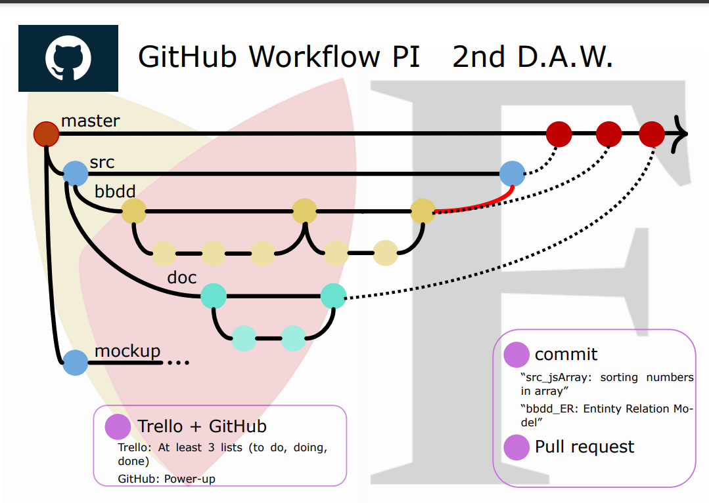

**COMMIT MESSAGE:**

 Finished func 1, front-end || hotfix on database table users

 Fixing Stuff || A || asdkrenwefhasakdaa

All the commits will be in English

The commits will have a **clear but short message of our work.**

The commits **couldn’t type as random characters or weird stuff**

